Event Management App Document

Installation Guide:

1. Download the project from the Github

3. import the project in Eclipse IDE or Visual Studio.

4. install node package and json server

5. run json server for local json server

6. then run the angular app

DESCRIPTION

Build an Angular app where the admin can view and manage employees.

Scenario:

You are working as a web developer and your company has decided to launch a

new app called Event Management. The administration team of the

organization can view and add their resources such as employees and keep their

data saved for future references.

The backend development has been outsourced as APIs and the frontend will be

developed in-house by using Angular as a client-side framework. During the

sprint planning, you agree to lead this project and develop an app that will let

the admin find employees using APIs outsourced by backend engineers.

The tasks that need to be performed by you are:

• Build the application using Angular

• Create a temporary database server for CRUD operation using a JSON local

server

• Validate all employee management forms using Form Validation

• Render the application as a Single Page Application

Tools Required:

• Angular

• Bootstrap

The Following Requirements Should Be Met:

• Admin login page where admin can change the password after logging in if

he wants to.

• Admin can view a master list of employee details.

• Admin can create, remove, update, or delete employee details.

Refer the following steps for JSON server creation:

1) Execute the command given below:

npm install -g json-server

2) Create a file with the name db.json and add the code given below:

{

"employees": [

{

"id": 1,

"first_name": "Sebastian",

"last_name": "Eschweiler",

"email": "sebastian@codingthesmartway.com"

},

{

"id": 2,

"first_name": "Steve",

"last_name": "Palmer",

"email": "steve@codingthesmartway.com"

},

{

"id": 3,

"first_name": "Ann",

"last_name": "Smith",

"email": "ann@codingthesmartway.com"

}

]

}

3) Add the code given below in the script section of your package.json file in the

root folder of your Angular application

"json:server": "json-server --watch db.json"

Note: Before executing your Angular Application, run the command given below

to start your json server:

npm run json-server

Sample URI to perform CRUD operations after running the json-server:

HTTP Methods URI Description

GET /employees Get all employees

GET /employees/1 Get employee by ID

POST /employees Add employee

PUT /employees Update employee

DELETE /employees/1 Delete employee by ID

1. Login Screen Admin will login here with credentials. We have used default id

and password here, later we add users

Email : r@gmail.com

Pass: 12345

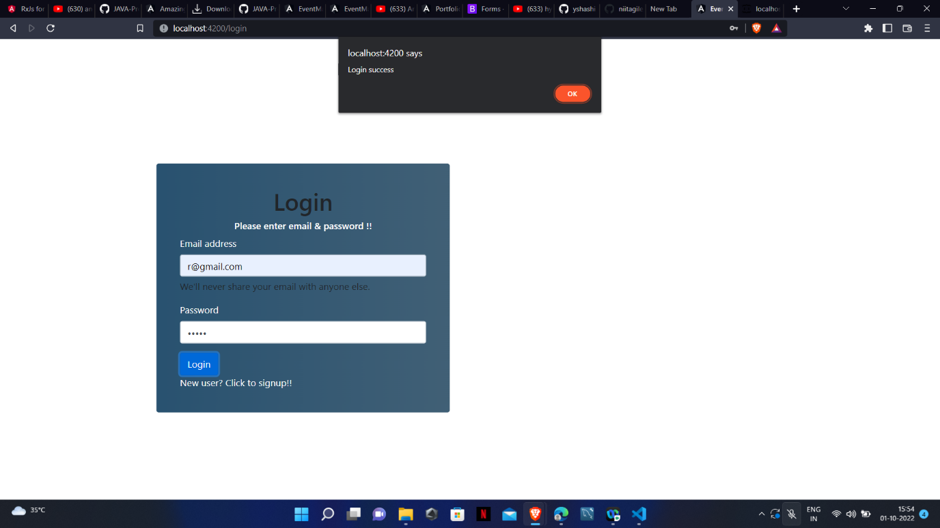

2. After Successful Login user admin will see all the employees and can do CRUD operations

like : add , edit and delete the employess.

